SLIDE 1

An exoplanet is any planet beyond our solar system. They are detected by astronomers by observing the intensity of their parent stars. Exoplanets are made up of elements similar to those of the planets in our solar system, but their mixes of those elements may differ. Some planets may be dominated by water or ice, while others are dominated by iron or carbon.

SLIDE 2

Exoplanets come in a wide variety of sizes, from gas giants larger than Jupiter to small, rocky planets about as big around as Earth or Mars. In the sixteenth century the Italian philosopher Giordano Bruno suggested that distant stars were similar to our Sun and therefore may harbor planets of their own.

SLIDE 3

Early claims to have detected exoplanets were made in the 19th century, notably by William Jacob. In 1855, he saw deviations in the orbits within the nearby 70 Ophiuchi binary star system. The first time we actually detected an exoplanet was in 1917 NASA’s JPL.

The first planet orbiting a star similar to the Sun was found in 1995. The planet was half the mass of Jupiter, at least and no more than twice its mass.

Now we live in a universe of exoplanets. The count of confirmed planets is in the thousands and rising. That’s from only a small sampling of the galaxy as a whole. The count could rise to the tens of thousands within a decade, as we increase the number, and observing power, of robotic telescopes lofted into space.

SLIDE 4

**WHY DO WE HUNT FOR EXOPLANETS**

•Observing exoplanets allows us to determine whether we actually understand those processes, even in our own solar system.

•In fact, what we’ve seen so far is that most stellar systems don’t look like our solar system.

•What finding exoplanets does for us is open up a vast exploration area to look for other habitable worlds. And it has upped the likelihood that we are not alone

SLIDE 5

EXPLAINING TYPES OF METHODS TO DETECT EXOPLANETS

**SLIDE 6**

**THE TELESCOPE WE ARE USING FOR THIS DATA**

**About Kepler Telescope**

The spacecraft was named after the famed German astronomer Johannes Kepler (1571-1630).

Kepler was equipped to look for planets with size spans from one-half to twice the size of Earth (terrestrial planets) in the habitable zone of their stars where liquid water might exist in the natural state on the surface of the planet.

Its scientific goals included determining the abundance of these planets and the distribution of sizes and shapes of their orbits, estimating the number of planets in multiple-star systems, and determining the properties of stars that have planetary systems.

Kepler detects planets by observing transits, or tiny dips in the brightness of a star that occur when a planet crosses in front of the star.

The spacecraft was basically a single instrument—a specially designed 3-foot diameter aperture telescope and image sensor array—with a spacecraft built around it. The diameter of the telescope’s mirror was 4 feet, 7 inches, one of the largest mirrors beyond Earth orbit.

Kepler was designed to monitor about 100,000 main-sequence stars over a period of three-and-a-half year

### **The Top Science Results from the Kepler Mission**

1. **Planets outnumber the stars.** Kepler has proven there are more planets than stars in our galaxy — and knowing that revolutionizes our scientific understanding of our place in the cosmos.
2. **Small planets are common.** Kepler has shown us our galaxy is teeming with terrestrial-size worlds; the most recent analysis of Kepler’s discoveries concludes that 20 to 50 percent of the stars in the sky are likely to have small, possibly rocky planets similar in size to Earth within the habitable zone of their parent stars, where water could pool on the planet surface.
3. **Planets are diverse.** Kepler has discovered a diversity of planet types, opening our eyes to new possibilities. The most common size of planet Kepler found doesn’t exist in our solar system — a world between the size of Earth and Neptune — and we have much to learn about these planets.
4. **Solar systems are diverse too!** While our own inner solar system has four planets, Kepler found systems with considerably more planets — up to eight — orbiting close to their parent stars.



This animation shows how a dip in the observed brightness of a star may indicate the presence of a planet passing in front of it, an occurrence known as a transit.

***Credits: NASA's Goddard Space Flight Center***

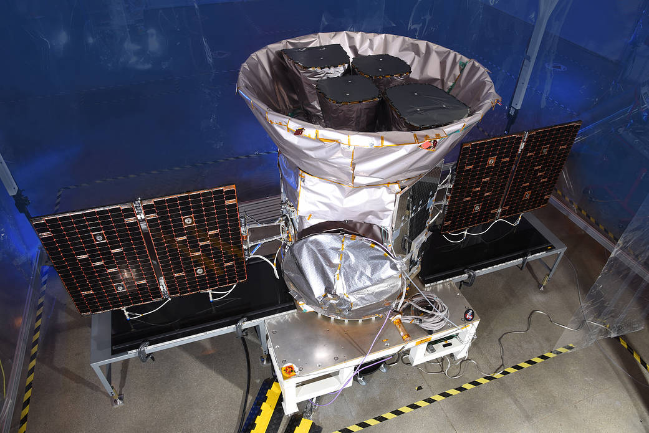

***The fully integrated Transiting Exoplanet Survey Satellite (TESS)***

***Image credit: Orbital ATK***

SLIDE 7

TRANSIT METHOD

The transit method is a photometric method that aims to indirectly detect the presence of one or more exoplanets in orbit around a star.

The transit method consists of regularly measuring the luminosity of a star in order to detect the periodic decrease in luminosity associated with the transit of an exoplanet. Based on how much of a dip in light a planet causes in its star, we can determine that planet’s size. Looking at how long it takes a planet to orbit its star, scientists are able to determine the shape of the planet’s orbit and how long it takes the planet to circle its sun.